

database management systems

Cycle Sheet – 1

­­

Name: **VIBHU KUMAR SINGH**

Reg. No: **19BCE0215**

Teacher: **Nancy Victor**

**1. Create all tables in Hospital database as per the requirement given below;**

**a) The primay key for each table to be created as specified (refer database)**

1. **Appropriate data type and size should be chosen for each attribute**
2. **Appropriate integrity constraints should be used while creating tables (NULL, NOT NULL, FOREIGN KEY, CHECK) - Refer Figure 1**
3. **The values for some attributes should be as follows; include appropriate CHECK constraints to achieve them.**
4. **Primary key values should be created with uniformity. For example, Doc_ID can be like ‘D0001’ [five characters long and start with ‘D’], Staff_ID like ‘S0001’, Pres_ID like ‘PR00001’ and so on.**

**Attributes and permitted values (you can decide and include such values wherever required)**

**A1.**

Doctor:

create table Doctor(

Doc_ID varchar2(5) primary key CHECK(Doc_id like 'D%' and length(Doc_ID)=5),

Doc_Name varchar2(25) not null,

Gender char(1) not null,

DOB date not null,

Specialist varchar2(25) not null CHECK(Specialist in ('Neurology','Diabetes','Ophthalmology','Cardiology','General medicine')),

Qualification varchar2(25) not null CHECK(Qualification in ('MBBS', 'MS', 'MD', 'BDS', 'MDS')),

Contact number(10) not null,

Address varchar2(30) not null,

Dept_No varchar2(4) not null

)

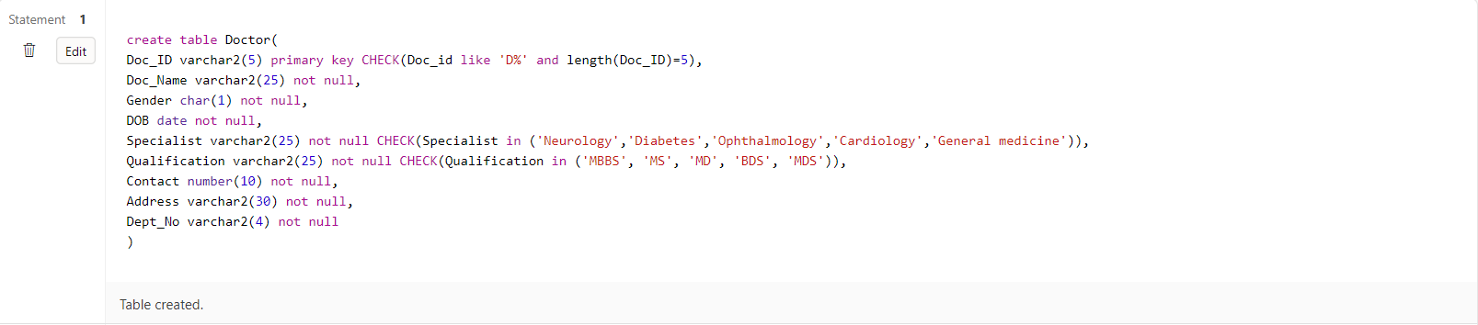

Department:

create table Department(

Dept_No varchar2(5) primary key CHECK(Dept_No like 'D%' and length(Dept_No)=4),

Dept_Name char(20) not null CHECK(Dept_Name in('Cardiology','Intensive care unit','Neurology','Oncology','Obstetrics and gynaecology','Diabetes')),

Dept_Room_No number(4) not null,

Dept_Floor number(2) not null,

Dept_HOD varchar2(10) not null,

Dept_Estd_Date date not null CHECK(Dept_Estd_Date > '01-Jan-2010')

)

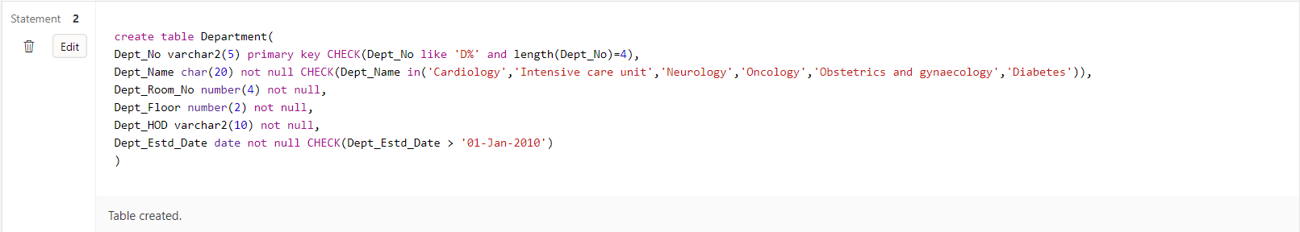

Staff:

create table Staff(

Staff_ID varchar2(5) primary key not null CHECK(Staff_ID like 'S%' and length(Staff_ID)=5),

Staff_Name varchar2(20) not null,

Categoryy varchar2(20) not null check(Categoryy in ('Nurse','Lab Technician','Attender','Helper')),

dob date,

Contact number(10) not null,

Address varchar2(100),

Dept_No varchar2(4),

Designation varchar2(100) not null check (Designation in ('Staff Nurse','Head Nurse','Technician','Senior Attender','Junior Attender'))

)

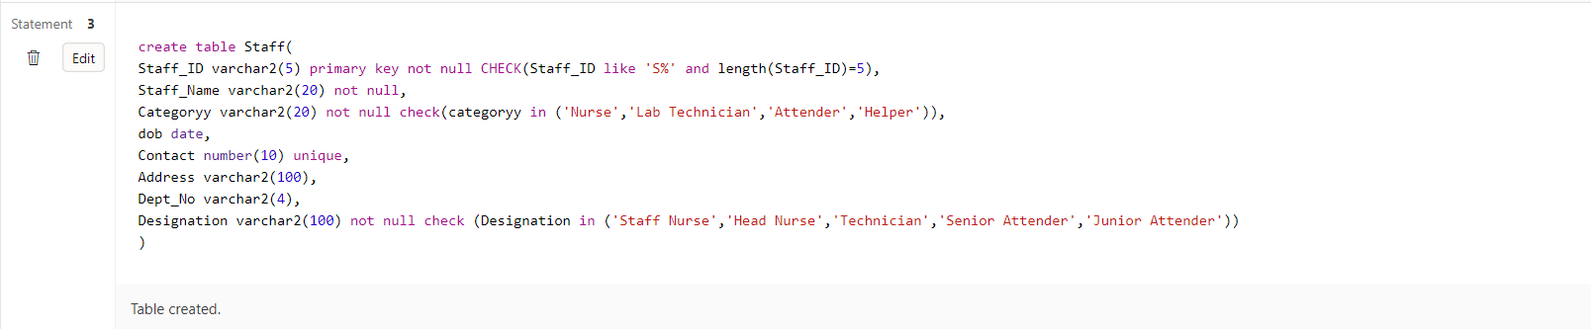

Patient:

create table Patient(

Pat_ID varchar2(5) primary key check( Pat_ID like 'PT%' and length(Pat_ID)=5),

Pat_Name varchar2(25) not null,

DOB date not null,

Gender char(1) not null check(Gender in ('M','F','T')),

Contact number(10) not null,

Address varchar2(30) not null

)

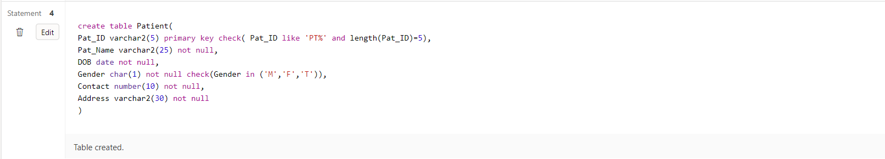

In_Patient:

create table In_Patient(

Pat_ID varchar2(5) not null,

Date_of_admission date not null,

Bed_No number(4) not null,

Start_Time timestamp not null,

End_Time timestamp not null,

CHECK(Start_Time BETWEEN Date_of_admission AND End_Time)

)

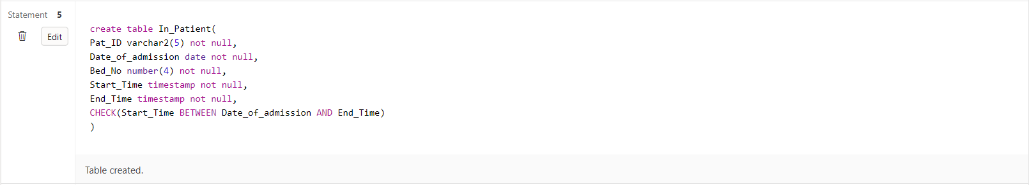

In_Patient_Prescription:

create table In_Patient_Prescription(

Pat_ID varchar2(5) not null CHECK( Pat_ID like 'PT%' and length(Pat_ID)=5),

Pres_ID varchar2(7) not null CHECK(Pres_ID like 'PR%' and length(Pres_ID)=7)

)

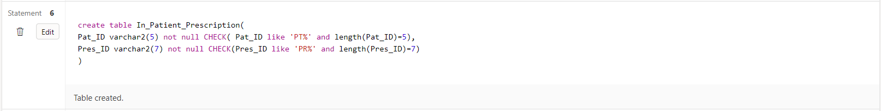

Appointment:

create table Appointment(

App_ID varchar2(5) primary key CHECK( App_ID like 'APP%' and length(App_ID)=5),

Pat_ID varchar2(5) not null,

Doc_ID varchar2(5) not null CHECK(Doc_id like 'D%' and length(Doc_ID)=5),

Nurse_ID varchar2(5) not null,

Consult_Room_No number(4) not null,

Date_ date not null,

time_ timestamp not null

)

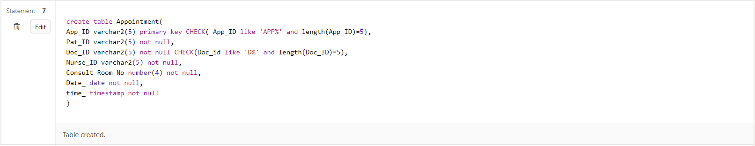

Prescription:

create table Prescription(

Pres_ID varchar2(7) primary key CHECK(Pres_ID like 'PR%' and length(Pres_ID)=7),

App_ID varchar2(5) CHECK( App_ID like 'APP%' and length(App_ID)=5),

Date_ date not null,

time_ timestamp not null,

Diagnosis_Detail varchar(30) not null

)

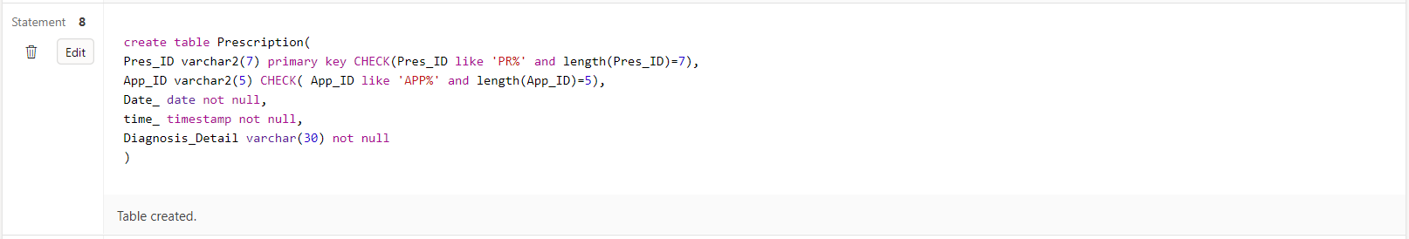

Prescribed_Medicines:

create table Prescribed_Medicines(

Pres_ID varchar2(7) CHECK(Pres_ID like 'PR%' and length(Pres_ID)=7),

Medicine_Name varchar2(15) not null,

Dosage varchar2(15) not null,

Brand varchar2(15) not null

)

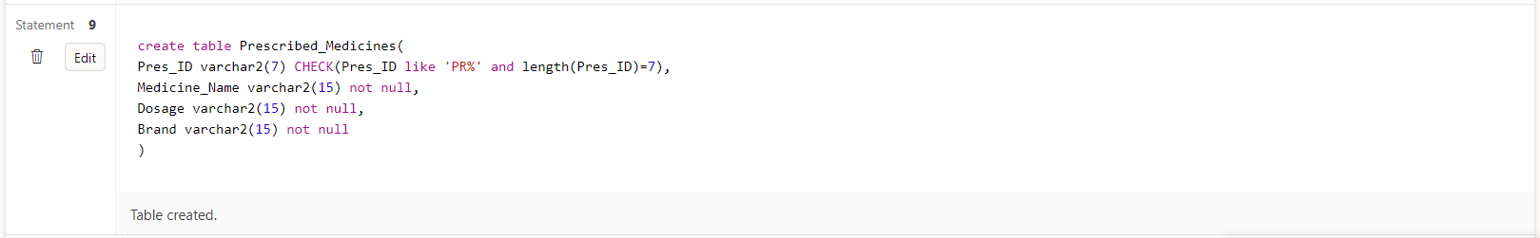

Hospital_Bill:

create table Hospital_Bill(

Inv_No varchar2(6) unique,

Inv_Date date not null,

Pat_ID varchar2(5) CHECK(Pat_ID like 'PT%' and length(Pat_ID)=5),

Bill_Amount number(8) not null,

Payment_Type varchar2(15) not null,

discount number(2) not null

)

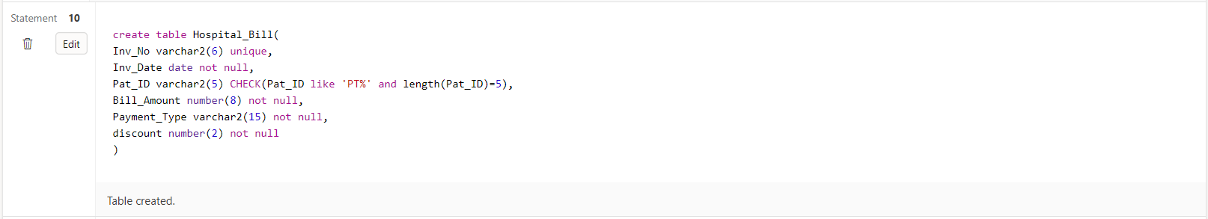

Lab_Tests:

create table Lab_Tests(

Test_ID varchar2(5) primary key CHECK(Test_ID like 'TI%' and length(Test_ID)=5),

Pat_ID varchar2(5) CHECK( Pat_ID like 'PT%' and length(Pat_ID)=5),

Date_ date not null,

time_ timestamp not null

)

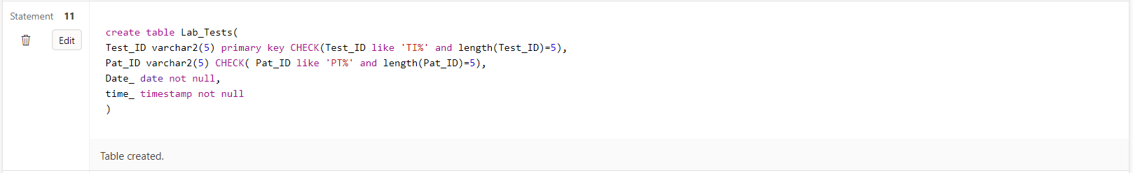

Test_Results:

create table Test_results(

Test_ID varchar2(5)CHECK(Test_ID like 'TI%' and length(Test_ID)=5),

TT_ID varchar2(5) CHECK( TT_ID like 'TT%' and length(TT_ID)=5),

Result varchar2(10) not null

)

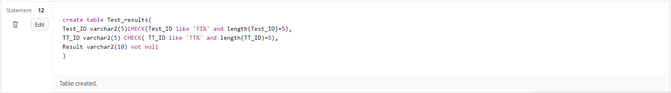

Test_Types:

create table Test_Types(

TT_ID varchar2(5) primary key CHECK( TT_ID like 'TT%' and length(TT_ID)=5),

Description varchar2(20) not null CHECK(Description in('Blood test','Urine test','Ultrasound test','Biopsy')),

Low_value number(4) not null,

High_value number(4) not null,

Test_method varchar2(15) not null,

Technician varchar2(5) not null

)

**SCHEMA:**

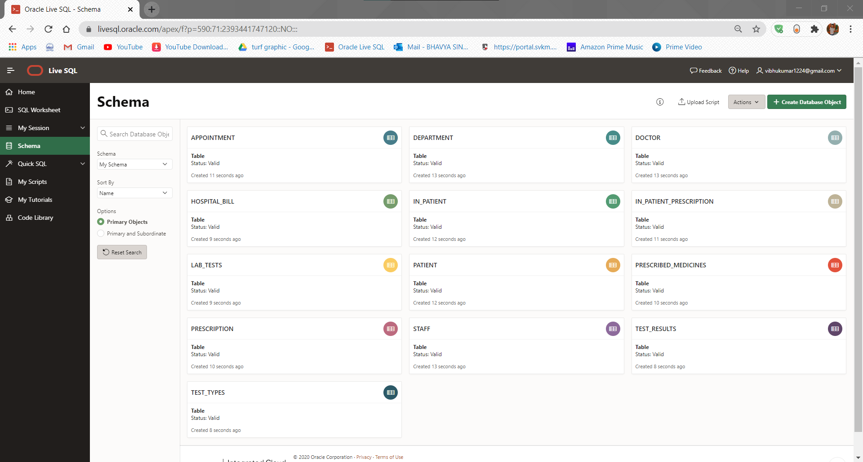

**Making foreign keys:**

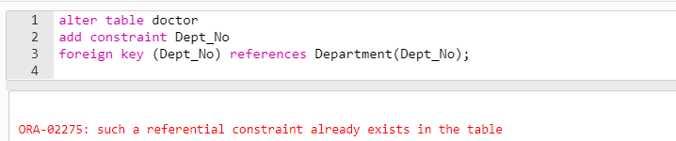

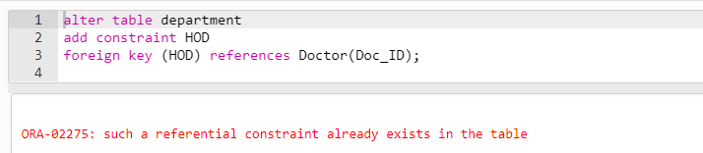

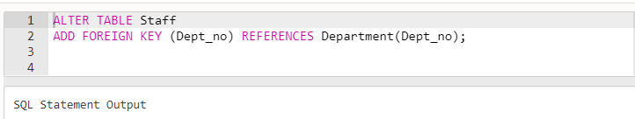

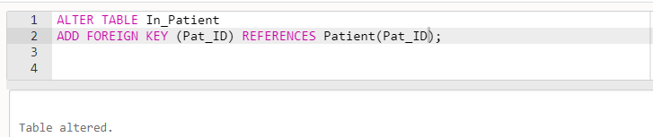

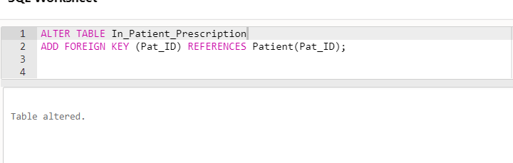

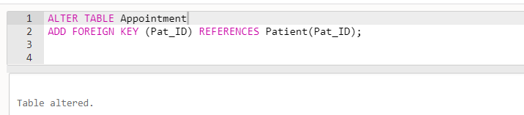

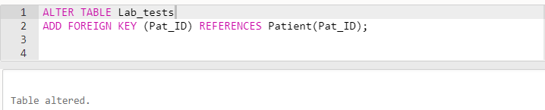

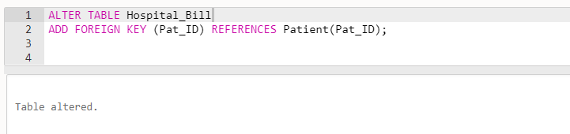

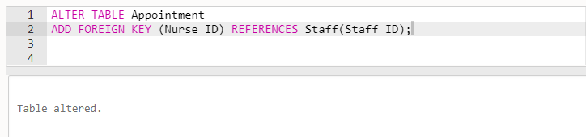

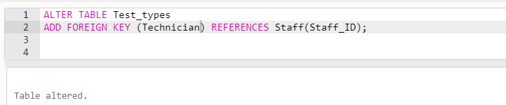

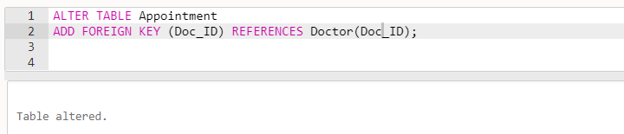

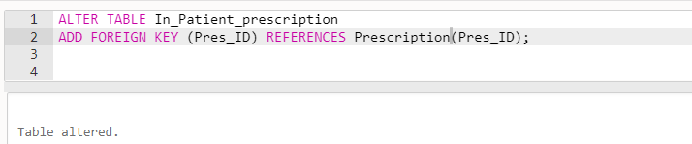

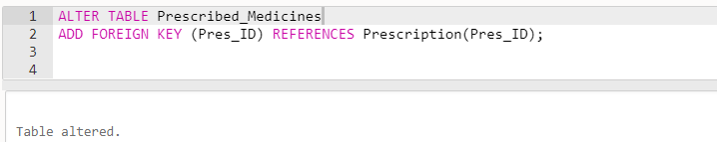

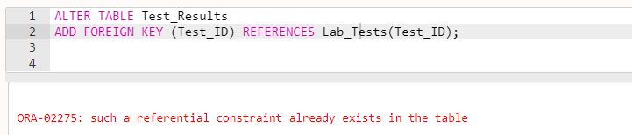

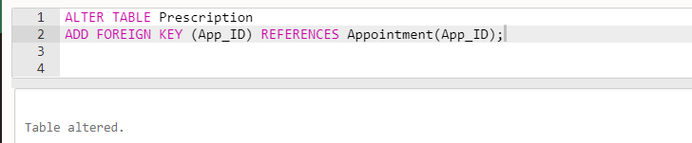

1. **Populate each table with appropriate, valid and meaningful data.**

**A2.**

Doctor:

insert into Doctor values('D0001','Vibhu Kumar Singh','M','01-Jan-1990','Neurology','MBBS',8529759229,'Vasundhara','D102');

insert into Doctor values('D0002','Lionel Messi','F','02-Jan-1990','Ophthalmology','MD',8529759230,'Ghaziabad','D102');

insert into Doctor values('D0003','Akansha Sharma','F','03-Jan-1990','Cardiology','MDS',8529759231,'Kavi Nagar','D100');

insert into Doctor values('D0004','Sanjay Kumar','M','01-Jan-1990','General medicine','MBBS',8529759232,'Shastri Nagar','D103');

insert into Doctor values('D0005','Zaheer Khan','M','01-Jan-1990','Neurology','BDS',8529759233,'South Delhi','D102');

Department:

insert into Department values('D102','Cardiology',1001,01,'D0001','1-Jan-2020');

insert into Department values('D100','Intensive care unit',1002,01,'D0002','2-Jan-2020');

insert into Department values('D101','Neurology',1003,03,'D0003','3-Jan-2020');

insert into Department values('D103','Oncology',1004,04,'D0004','4-Jan-2020');

insert into Department values('D190','Diabetes',1005,05,'D0005','5-Jan-2020');

Staff:

insert into Staff values('S0005','Sania','Nurse','01-Jan-1990',1234567892,'Jhotwara','D102','Staff Nurse');

insert into Staff values('S0001','Sam','Lab Technician','02-Jan-1990',1234567893,'Jaipur','D102','Technician');

insert into Staff values('S0002','Ramesh','Attender','03-Jan-1990',1234567894,'Jaisalmer','D100','Junior Attender');

insert into Staff values('S0003','Suresh','Nurse','04-Jan-1990',1234567895,'Goa','D101','Staff Nurse');

insert into Staff values('S0004','Manju','Nurse','05-Jan-1990',1234567891,'Pakistan','D190','Junior Attender');

Patient:

insert into Patient values('PT001','Sam','01-Jan-2000','M',8529759249,'Thane West');

insert into Patient values('PT002','mary','02-Jan-2000','F',8529759257,'Thane East');

insert into Patient values('PT003','Kevin','03-Jan-2000','M',8340613668,'Chennai');

insert into Patient values('PT004','Jay','04-Jan-2000','M',8529659228,'Borivali West');

insert into Patient values('PT005','Nancy','05-Jan-2000','F',8526759234,'Worli');

In_Patient:

insert into In_Patient values('PT001','01-Jan-2020',1010,to_timestamp('2020-11-03:08:49:01','YYYY-MM-DD HH24:MI:SS'),to_timestamp('2020-11-03:09:49:01','YYYY-MM-DD:HH24:MI:SS'));

insert into In_Patient values('PT002','02-Jan-2020',1012,to_timestamp('2020-10-04:09:34:01','YYYY-MM-DD:HH24:MI:SS'),to_timestamp('2020-10-04:11:34:01','YYYY-MM-DD:HH24:MI:SS'));

insert into In_Patient values('PT001','03-Jan-2020',1013,to_timestamp('2020-04-11:10:23:01','YYYY-MM-DD:HH24:MI:SS'),to_timestamp('2020-04-11:12:23:01','YYYY-MM-DD:HH24:MI:SS'));

insert into In_Patient values('PT004','04-Jan-2020',1014,to_timestamp('2020-06-20:11:55:01','YYYY-MM-DD:HH24:MI:SS'),to_timestamp('2020-06-20:13:55:01','YYYY-MM-DD:HH24:MI:SS'));

insert into In_Patient values('PT005','05-Jan-2020',1015,to_timestamp('2020-05-07:07:23:01','YYYY-MM-DD:HH24:MI:SS'),to_timestamp('2020-05-07:09:23:01','YYYY-MM-DD:HH24:MI:SS'));

insert into In_Patient values('PT004','01-May-2020',100,to_timestamp('2020-11-03:08:49:01','YYYY-MM-DD HH24:MI:SS'),to_timestamp('2020-11-03:09:49:01','YYYY-MM-DD:HH24:MI:SS'));

insert into In_Patient values('PT002','01-May-2020',100,to_timestamp('2020-11-03:08:49:20','YYYY-MM-DD HH24:MI:SS'),to_timestamp('2020-11-03:09:49:01','YYYY-MM-DD:HH24:MI:SS'));

In_Patient_Presciption:

insert into In_Patient_Prescription values('PT001','PR00001');

insert into In_Patient_Prescription values('PT002','PR00002');

insert into In_Patient_Prescription values('PT003','PR00003');

insert into In_Patient_Prescription values('PT004','PR00012');

insert into In_Patient_Prescription values('PT005','PR00005');

Appointment:

insert into Appointment values('APP01','PT001','D0001','S0003',111,'01-Jan-2020',to_timestamp('2020-11-01:09:49:01','YYYY-MM-DD:HH24:MI:SS'));

insert into Appointment values('APP02','PT002','D0002','S0005',111,'02-Jan-2020',to_timestamp('2020-10-22:11:30:01','YYYY-MM-DD:HH24:MI:SS'));

insert into Appointment values('APP03','PT003','D0003','S0005',111,'03-Jan-2020',to_timestamp('2020-04-13:08:49:01','YYYY-MM-DD:HH24:MI:SS'));

insert into Appointment values('APP04','PT004','D0004','S0003',112,'04-Jan-2020',to_timestamp('2020-06-23:12:34:01','YYYY-MM-DD:HH24:MI:SS'));

insert into Appointment values('APP05','PT005','D0005','S0003',113,'05-Jan-2020',to_timestamp('2020-05-16:13:40:01','YYYY-MM-DD:HH24:MI:SS'));

insert into Appointment values('APP06','PT003','D0001','S0003',111,'11-Jan-2020',to_timestamp('2020-11-01:09:49:01','YYYY-MM-DD:HH24:MI:SS'));

insert into Appointment values('APP07','PT002','D0001','S0003',111,'11-Jan-2020',to_timestamp('2020-11-01:09:49:01','YYYY-MM-DD:HH24:MI:SS'));

Prescription:

insert into Prescription values('PR00001','APP01','01-Jan-2020',to_timestamp('2020-11-01:09:49:01','YYYY-MM-DD:HH24:MI:SS'),'High BP');

insert into Prescription values('PR00002','APP02','02-Jan-2020',to_timestamp('2020-10-22:11:30:01','YYYY-MM-DD:HH24:MI:SS'),'Low Vitamins');

insert into Prescription values('PR00003','APP03','03-Jan-2020',to_timestamp('2020-04-13:08:49:01','YYYY-MM-DD:HH24:MI:SS'),'Low Bone Density');

insert into Prescription values('PR00012','APP04','04-Jan-2020',to_timestamp('2020-06-23:12:34:01','YYYY-MM-DD:HH24:MI:SS'),'Anaemia');

insert into Prescription values('PR00005','APP05','05-Jan-2020',to_timestamp('2020-05-16:13:40:01','YYYY-MM-DD:HH24:MI:SS'),'Fracture');

Prescribed_Medicines:

insert into Prescribed_medicines values('PR00001','crocin','10mg','Hamway');

insert into Prescribed_medicines values('PR00002','Combiflame','15mg','Hamway');

insert into Prescribed_medicines values('PR00003','SHA256','10ml','HDM');

insert into Prescribed_medicines values('PR00012','SHA1','20ml','HDM');

insert into Prescribed_medicines values('PR00005','SHA128','15ml','Hamway');

Hospital_Bill:

insert into Hospital_Bill values('4072','01-Jan-2020','PT001',150000,'cash',5);

insert into Hospital_Bill values('4073','02-Jan-2020','PT002',200000,'credit card',10);

insert into Hospital_Bill values('4074','03-Jan-2020','PT003',40000,'debit card',5);

insert into Hospital_Bill values('4075','04-Jan-2020','PT004',3000,'cash',10);

insert into Hospital_Bill values('4078','05-Jan-2020','PT005',5000,'debit card',15);

Lab_Test:

insert into Lab_tests values('TI001','PT001','01-Jan-2020',to_timestamp('2020-11-03:08:49:01','YYYY-MM-DD:HH24:MI:SS'));

insert into Lab_tests values('TI002','PT002','02-Jan-2020',to_timestamp('2020-10-04:09:34:01','YYYY-MM-DD:HH24:MI:SS'));

insert into Lab_tests values('TI003','PT003','03-Jan-2020',to_timestamp('2020-04-11:10:23:01','YYYY-MM-DD:HH24:MI:SS'));

insert into Lab_tests values('TI004','PT004','04-Jan-2020',to_timestamp('2020-06-20:11:55:01','YYYY-MM-DD:HH24:MI:SS'));

insert into Lab_tests values('TI005','PT005','05-Jan-2020',to_timestamp('2020-05-07:07:23:01','YYYY-MM-DD:HH24:MI:SS'));

Test_results:

insert into Test_results values('TI001','TT001','Positive');

insert into Test_results values('TI002','TT002','Positive');

insert into Test_results values('TI003','TT003','Negative');

insert into Test_results values('TI004','TT004','Negative');

insert into Test_results values('TI005','TT005','Positive');

Test_Types:

insert into Test_Types values('TT001','Blood test',26,66,'Blood sample','S0004');

insert into Test_Types values('TT002','Blood test',23,65,'Blood sample','S0004');

insert into Test_Types values('TT003','Urine test',30,74,'Urine sample','S0004');

insert into Test_Types values('TT004','Urine test',11,23,'Urine sample','S0004');

insert into Test_Types values('TT005','Urine test',15,24,'Urine sample','S0004');

1. **Add some attributes with few tables and justify the additions.**

**A3.**

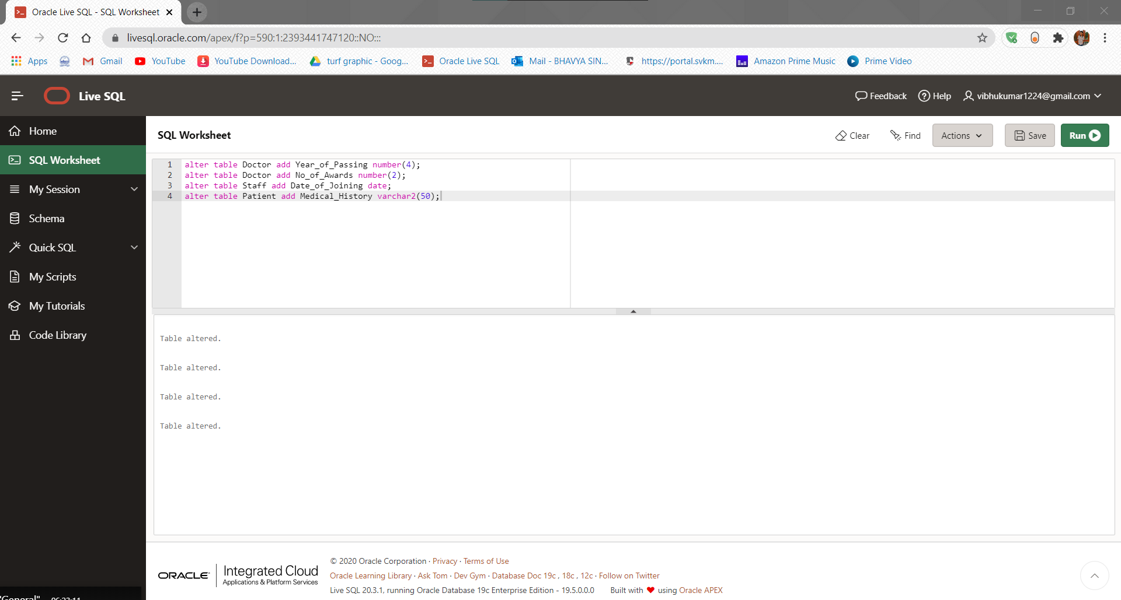

**Justification for the addition of the above attributes:**

* A doctor may be considered for a position like the HOD of a department based on his experience and the no. of awards he has bagged throughout the course of his career.
* Similarly, for staff, their promotions may be decided on the basis of the years they have served in the hospital.
* A patient’s previous medical records can help a doctor analyze the situation well and consequently better aid the patient.

1. **Write DML queries to achieve the following;**
2. **Find the details of all doctors.**
3. **Display all the hospital bill details.**
4. **List the doctors who are specialized in ‘Cardiology’ and ‘Neurology’**
5. **List all the appointments made for consultation room number 111, on ’11-Jan- 2020’.**
6. **Display all the test types that have the values in the range of 25 and 75.**
7. **Find the diagnosis details of the patient with prescription id ‘PR00012’.**
8. **Display the name of the patients whose gender is female or the contact number is 9878987890.**
9. **Find the staff name and staff id who are not working in the department ‘D102’**
10. **Find the patients who are admitted on ’01-May-2020’ in the bed 100.**
11. **Delete the test results that are ‘Positive’**
12. **Increase the discount with 5% more for all the patients whose bill amount is greater than 100000.**
13. **Change the HOD of cardiology department with doctor ‘D0003’**
14. **Delete the prescribed medicines records that have the brand name ‘XYZ’**
15. **Modify the low value and high value to 10 and 30 respectively for the clinical test ‘urine’**
16. **Update the contact number of all staffs who are in the category ‘Nurse’**
17. **Delete the staff records that have designations ‘junior attender’ or ‘technician’ and belongs to the department ‘D190’.**

**A4.**

1. select * from Doctor;

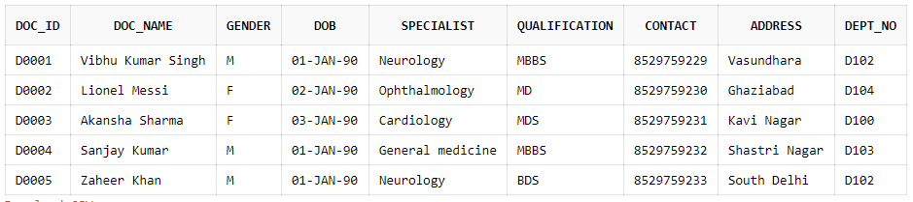

1. select * from Hospital_bill;

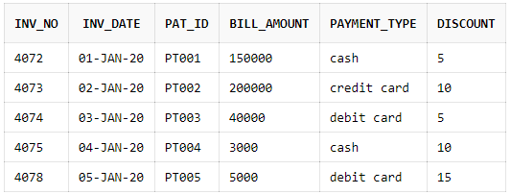

1. select * from Doctor where specialist in ('Cardiology','Neurology');

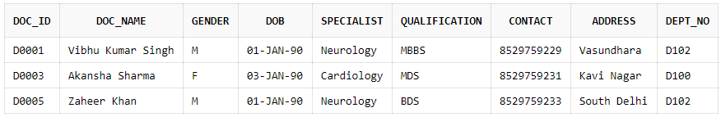

1. select * from Appointment where Consult_Room_No = 111 and Date_ = '11-Jan-2020';

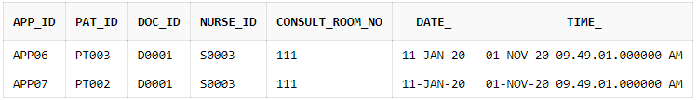

1. select * from Test_Types where Low_value>= 25 and High_value<= 75;

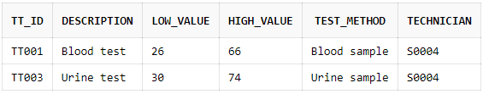

1. select Diagnosis_Detail from Prescription where pres_id = 'PR00012';

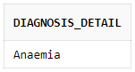

1. select Pat_Name from Patient where gender = 'F' or contact = 9414486833;

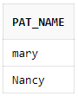

1. select Staff_Name, Staff_ID from staff where dept_no not in 'DP102';

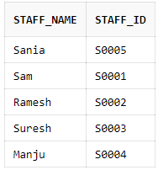

1. select * from In_Patient where Bed_no=100 AND Date_of_admission='01-May-2020';

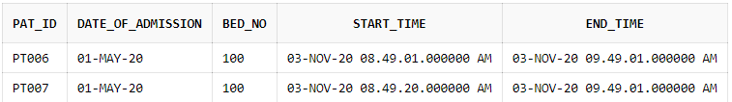

1. delete from Test_results where Result='Positive';

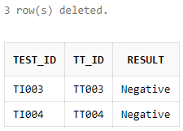

1. update Hospital_Bill set discount=discount+5 where Bill_Amount>100000;

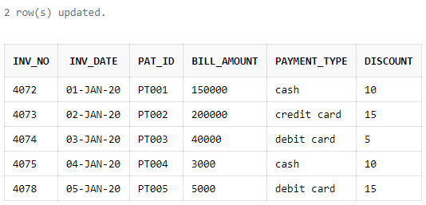

1. update Department SET Dept_HOD='D0003' where Dept_name='Cardiology';

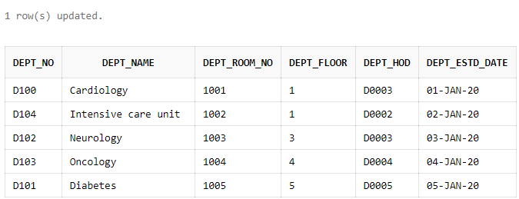

1. delete from Prescribed_Medicines where Brand='Hamway';

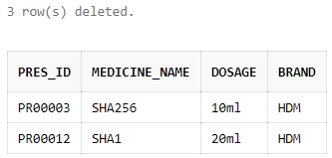

1. update Test_Types set Low_value=10 where Description='Urine Test';

update Test_Types set High_value=30 where Description='Urine Test';

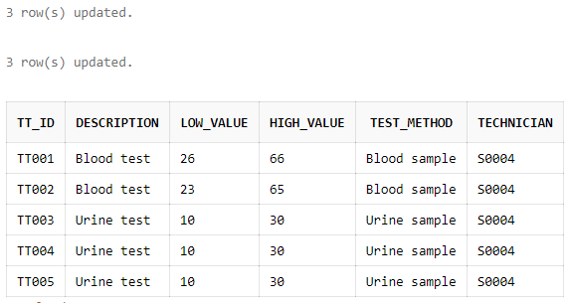

1. update Staff set Contact=9836278675 where Categoryy='Nurse';

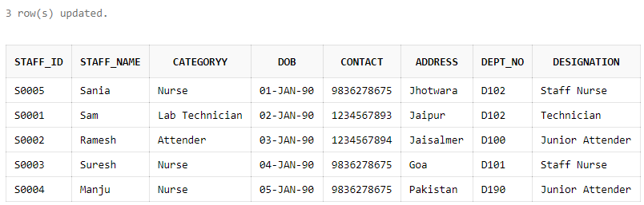

1. delete from Staff where Designation in ('Junior Attender', 'Technician') and Dept_No = 'D190';

